Sustainability reporting in the pharmaceutical sector: Prescription for pharma
Sustainable development is vital to not only improving a company's commitment to its stakeholders but also in reducing costs through efficient use of scarce resources and processes. Kshama V Kaushik and Rosanna M Vetticad, in this sustainability report, conducts a study about top 10 Indian pharmaceutical companies and present a prescription for the industry
Rosanna M M Vetticad | Kshama V Kaushik
Sustainable development is vital to not only improving a company’s commitment to its stakeholders but also in reducing costs through efficient use of scarce resources and processes. The pharmaceutical industry consumes large quantities of economic, natural and human resources. The Indian pharma industry is one of the largest in the world in terms of volume. It has been growing at a rapid pace post the liberalisation of the 1990s and changes in the Indian patent laws in 2005. In order to maintain and grow this stature, the industry will have to demonstrate commitment to sustainable development by use of innovative approaches to manufacturing processes and developing cleaner technologies. Sharing sustainable practices through the supply chain is also crucial as a symbiotic relationship exists between a company and its stakeholders including customers and suppliers.
Indian pharma industry - background
The Department of Pharmaceuticals (DoP) administers the Indian pharma industry set up under the Ministry of Chemicals and Fertilisers in 2008, with a vision to make India the largest global provider of quality medicines at reasonable prices1.
According to the DoP, the Indian pharma industry ranks third globally in terms of volume and 14th in terms of value. This represents around 10 per cent of the total global production and also 20 per cent of the total volume of global generics. Thus every fifth tablet, capsule and injectable in generics drugs consumed anywhere in the world is manufactured in India2. From a $1 billion industry in 1990 it has grown to an over $20 billion industry in 2010 (40 per cent of which are exports). The Indian industry now produces bulk drugs belonging to all major therapeutic groups requiring complicated manufacturing technologies. India is the only country with the largest number of US FDA compliant plants (more than 100) outside US, 793 WHO-GMP approved plants, and 153 European Directorate of Quality Medicines (EDQM) approved plants with modern state of art technology.

Financial performance and growth
Table 1: Projected growth (Rs crores)
Year | 2010-11 | 2016-17* | 2019-2020*
Turnover | 1,04,944 | 288,000 | 481,000
*projections
The industry has witnessed robust growth since the beginning of the 11th Plan in 2007 and continues to grow rapidly3. The Annual Report of the DoP forecasts a 14 per cent increase in revenue in 2011-12 vis-à-vis 2010-11. This increase is driven primarily by export oriented companies as the sharp depreciation of the rupee is expected to result in higher export realisation. The DoP projects the industry to grow to Rs 288,000 crores by 2016-17 and Rs 481,000 by 2019-20.
Fig 1: Growth of Indian Pharma Industry
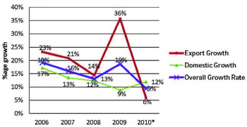
Fragmented industry
Table 2: Turnover-wise distribution of units
Turnover (Rs crores) | per cent distribution
0-10 crore | 70 per cent
10-50 crore | 20 per cent
50-100 crore | 5 per cent
100-500 crore | 3 per cent
500 + crore | 2 per cent
The Indian pharma industry is a large and fragmented one. It comprises of approximately 10,500 units, most of which are in the unorganised sector. 300-400 of these fall in the medium to large organised sector. It is interesting to note that 36.5 per cent of the total market share is contributed by the top 10 manufacturers. The medium and large domestic companies in fact have been the drivers of growth, contributing 75 per cent of domestic sales and over 90 per cent of exports4.
However, only two per cent of units in India are Rs 500+ crore generating units, whereas 70 per cent of all the units have turnovers of only up to Rs 10 crores5. With blockbuster drugs getting off-patented and resultant rising R&D costs it is becoming increasingly difficult for global companies to maintain their bottom-lines. In order to save costs therefore they have resorted to outsourcing R&D and manufacturing activities. A research cited by the working group set up by the planning commission suggests that this segment is expected to grow by 30-35 per cent6.

Fig 2: Turnover-wise Distribution of Units
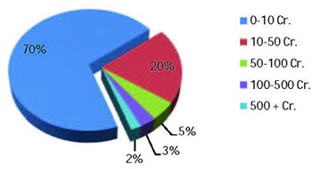
Sustainability reporting requirements
The pharma sector does not have any specific sustainability reporting requirements in India or globally, whether mandatory or recommendatory in nature. However globally accepted reporting frameworks applicable to all sectors can also be used by the pharma sector. These are:
- Environment impact assessment
- UN Global Compact (UNGC) and Communication on progress
- Carbon disclosure project
- Global Reporting Initiative (GRI) framework
- Business Responsibility Report (BRR) and National Voluntary Guidelines (NVG) issued by SEBI and ministry of corporate affairs
Companies in the sample (Indian/global)
Table 3: Sample of Indian companies
Company | Net Sales (Rs Crores)
Ranbaxy Laboratories Ltd | 7,687
Cipla Limited | 6,978
Dr. Reddy's Laboratories Ltd | 6,686
Lupin Ltd | 5,364
Aurobindo Pharma Ltd | 4,285
Sun Pharmaceutical Industries Ltd | 4,016
Cadila Healthcare Ltd | 3,152
Jubilant Life Sciences Ltd | 2,641
Wockhardt Ltd | 2,560
Ipca Laboratories Ltd | 2,353
For the purpose of this report we have selected the top 10 Indian pharma companies based on net sales as per their latest available annual reports7.
As indicated above, these companies only form part of the two per cent group of all the pharma units in the country, whereas a majority of the units fall in the significantly smaller revenue segments (Refer Section- Fragmented Industry). The top 10 global pharma companies (based on sales) have been selected from Forbes’ ninth annual list of Global 2000 companies published in April 20128.
Fig 3: Types of Reports
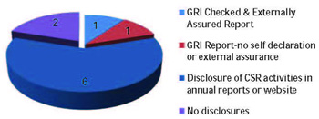
Quality of sustainability/CSR reporting of Indian companies
Of the 10 Indian companies in our sample only two have detailed sustainability reports, also observed in a joint research study conducted by the Deutsche Gesellschaft für Internati-onale Zusammenarbeit (GIZ) India, the Global Reporting Initiative (GRI) Focal Point India, and Thought Arbitrage Research Institute (TARI)– “Sustainability Reporting Practices and Trends in India 2012.” According to the report, considering the large manufacturing base in India, the pharma sector lags considerably behind in reporting on sustainability9.
Table 4: Sample of global companies
Rank | Company | Country | Sales
34 | Pfizer | United States | $67.4 B
62 | Novartis | Switzerland | $58.6 B
78 | Sanofi | France | $43.2 B
80 | Merck & Co | United States | $48 B
103 | Roche Holding | Switzerland | $45.3 B
119 | GlaxoSmithKline | United Kingdom | $42.5 B
127 | Abbott Laboratories | United States | $38.9 B
142 | AstraZeneca | United Kingdom | $32.4 B
208 | Eli Lilly & Co | United States | $24.3 B
217 | Bristol-Myers Squibb | United States | $21.2 B
Both the companies mentioned above used the GRI reporting framework, however only one company, viz Jubilant Life Sciences has a published report that is self-declared, externally assured, with a GRI checked application level of A+. This means that it has made all profile disclosures, all disclosures on management approach and applied all core performance indicators set out in the GRI framework under each of the economic, environmental and social categories, or provided reasons for omission of any indicator10. The company has been publishing its sustainability performance since 2003; this report covers the period April 1, 2011 to March 31, 2012 and was prepared under the GRI-G3.1 reporting guidelines.
The second company referred to above (viz. Dr Reddy's Laboratories) has been reporting on its environment, economic and social performance for several years now, the eighth report being for the two-year period April 1, 2010 to March 31, 2012. The report has been prepared in accordance with the GRI G3 reporting framework11.
Fig 4: Types of Reporting by Global companies
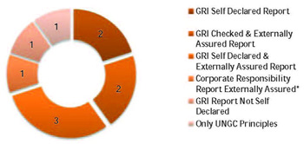
*No specific framework followed
Six of the remaining eight companies have discussed corporate social responsibility (CSR) activities and/or various aspects of their environment, economic and social performance either through disclosures in their annual reports or on their websites or both. No specific reporting framework has been adopted and the degree and extent of disclosures vary from company to company.
The two remaining companies, viz. Sun Pharmaceuticals and Wockhardt do not mention any aspect of sustainability or CSR activities either in their annual report or on their websites. In fact, the annual report of Sun Pharmaceuticals for the year 2011-12 is not available on the company website; the annual report for 2010-11 simply makes the following statement –“At the close of a relatively event-free, disaster-free year, your company persisted with participation in activities at the local, grassroots level across health and education. In the past, support has been offered towards disaster relief as well as participation in the facilitation of civic utilities around the plants / research centers. Your company remains interested in these contributions12.”
In contrast with the above, although the extent of reporting may vary, all global corporations in our selection have published Sustainability Reports – whether separately or on their websites.
Figure 5: Risk Disclosures
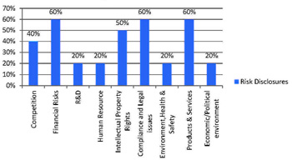
Risks identified/ risks reported by Indian companies
The risks identified the Indian companies in their annual / sustainability reports are shown in Figure 5: Risk Disclosures.
Jubilant Life Sciences which has a GRI checked A+ application level sustainability report has discussed its key risks in the Sustainability and Annual Reports. Key risks identified in the Sustainability Report and not mentioned in the MDA of the Annual Report are- Business Interruption Due To Force Majeure and Third Party Liability Risks. Additional risks discussed in Annual report not included in the Sustainability Report are - Capacity Planning and Optimisation, R&D Effectiveness and Portfolio & Mix: Customer and Product Concentration. Thus complete correlation does not exist between risks identified in the two reports.
Dr. Reddy’s Sustainability Report does not discuss any risks.
Fig 6: Risks Addressed by Global Companies
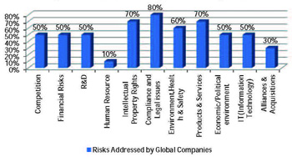
Risks identified by Indian vis-à-vis global companies
In addition to the above risks that have been identified by Indian companies, global corporations identify two additional risks, risks related to information technology and alliances and acquisitions.
The risks associated with information technology are the risk of exposing critical information or sensitive data regarding business due to information security systems and risk of losing information from cyber or hacker attacks. Alliances and acquisitions related risks are the risks associated with acquiring other businesses or disposing businesses.
It is interesting to note the difference in coverage between Indian and global companies when it comes to environment health and safety related risks. While the 60 per cent of the global companies in our sample have identified it as a risk, only 20 per cent of the Indian companies have.
CSR/Sustainability matters reported by companies in the sample
Here we discuss the CSR initiatives taken by the companies in our sample. As two companies have published sustainability reports and two companies do not discuss CSR either in their annual reports or the websites, the discussion below is limited to the matters reported by the remaining six companies. The extent and quality of discussions varies from report to report. Matters discussed include:
Fig 7: Environment Aspect
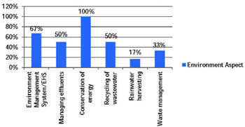
Environment: Four of the six companies covered in Figure 7 have included a discussion on their environment management or environment health and safety systems. Although, as indicated above, hardly any of the companies have identified any environment related risks. There is no discussion either bio-hazards. Three companies have discussed management of effluents and reduction of their carbon footprint, as well as measures for recycling waste water. It is no surprise that all six companies have made disclosures related to conservation of energy and the measures undertaken to achieve this, as such a disclosure is a statutory requirement under the companies Act, 1956. The two companies excluded from the chart have also made these disclosures (related to conservation of energy).

Fig 8: Social Aspects
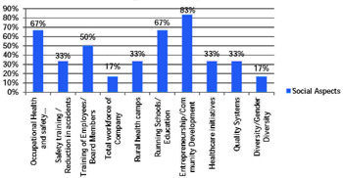
Social: Almost all companies have undertaken community development work which has been discussed in the annual reports. This includes low cost sanitation and housing, installation of drinking water huts, economic development of communities including skills up-gradation, etc. four out of six were engaged in providing education in the rural areas in which they operate, providing scholarships to deserving students, helping local schools with stationery, carpets, etc. Similarly four of the six companies provided information on occupational health and safety and measures taken to achieve this. Only two companies discussed their quality systems, safety trainings and health care initiatives like rural health camps, healthcare education, palliative care, price reduction in select drugs.
Supply chain management: Considering that contract manufacturing is a growing element in the pharma industry, none of the companies barring one has had a detailed discussion on their suppliers and how they ensure sustainable practices at the supplier end.
Dr Reddy’s has a rather extensive discussion in their sustainability report on ‘sustainable sourcing.’ It recognises that every action by individual business associates has the potential to impact the sustainability of every other associate they interact with. For this purpose they have embedded good sustainable practices among all business partners by mentoring each member of the supply chain. Best practices on safety related aspects are also shared with vendors. The company holds bi-annual meets with business partners to focus on quality with periodic training on quality and all new vendors are mandatorily required to undergo a supplier induction training to sensitise them to the company’s business processes and culture.
Jubilant Life Sciences merely touches upon the subject. Their sustainability report mentions that they have a “Green Supply Chain Policy” which also includes ensuring human rights. Under this policy, the supply chain management division is required to ensure that “human rights and related commitments are obtained from the contractors and suppliers” in the contracts signed with them.
None of the remaining eight companies discusses this subject in their annual reports or their websites.

Fig 9: Estimated Counterfeiting in 2012 (Rs Crores)
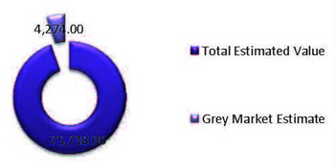
Counterfeiting: Counterfeiting is a major risk in the pharma industry world-over. World Health Organisation (WHO) defines counterfeit medical products as ones that are “deliberately and fraudulently mislabeled with respect to identity and / or source” (WHO/IFPMA, 1992)13. Unlike substandard medicines where there are problems with the manufacturing process by a known manufacturer, spurious / falsely-labelled /falsified /counterfeit medicines are made by people with the intent to mislead 14.
Any kind of counterfeiting therefore has far reaching consequences in terms of social impacts as it affects public health and safety standards thereby threatening human life. Developing countries like India are particularly vulnerable due to weak regulatory control and enforcement. The problem is further exacerbated by factors like scarcity and/or erratic supply of basic medicines, uncontrolled distribution chains, large price differentials between genuine and counterfeit medicines, lack of effective intellectual property rights protection, etc15.
A report prepared by TARI for FICCI Committee Against Smuggling and Counterfeiting Activities Destroying the Economy (CASCADE) makes an estimate of the total loss to the industry. According to this report, this is the only sector in India where the Ministry of the Government of India has acknowledged that a counterfeiting market exists, the size of which is 4.95 per cent16. The Planning Commission has estimated a domestic market size including imports at Rs 66,437 crores in 2010. Using a compounded annual growth rate of 14 per cent17, the size of the market has been estimated at Rs 75, 738 for 2012. Considering a grey market of 5 per cent, the estimated loss to the industry stands at approximately Rs 4, 274 crores 18.
Estimates made by different agencies vary drastically. Irrespective of the variance in estimates, the analysis above clearly indicates the magnitude of the problem. It would however be pertinent to note that in the sample selected for this report, none of the companies has identified counterfeiting as a risk inherent to the industry.
In fact most of the companies have not even discussed the issue even briefly. While three companies (Ranbaxy, Dr, Reddy’s and Cadila) have briefly mentioned the initiatives taken by them to prevent counterfeiting either in their annual reports or sustainability report, seven have made no mention of counterfeiting at all.
Fig 10: Counterfeiting in Annual Reports
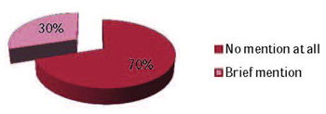
Biohazards and the environment
The Indian pharma industry evolved around industrial development clusters set up by various state governments at a time when there was no stringent of environment laws. International customers from developed nations however insist on compliance with local environmental standards which is a big challenge for the industry particularly the small scale units19. In order to see its vision of promoting environmentally sustainable development of the pharma industry come to fruition the DoP has to play a pivotal role in providing financial and technical assistance to improve the financial sustainability of SMEs on one hand and also safeguard the environment from the hazards associated with unplanned growth. Our analysis above shows that hardly any of the companies has made any disclosures in this risk or even identified it as a significant risk.
Way forward
Sustainability reporting in India is still in an early stage across all sectors and only a limited number of organisations exhibit a continued commitment for disclosures. The analysis above clearly shows that the pharma industry in India is way behind in its sustainability reporting practices. Although reporting on sustainability metrics is predominantly voluntary, with the steadily increasing importance that it is gaining globally, companies will have to start reporting on the impact they have on the economy, the environment, society and the organisation itself.
In the Indian context specifically companies across industries will have to gear up to comply with the recently introduced regulatory requirements viz. Business Responsibility Reports (BRRs) and section 135 of the new Companies Bill. BRRs are already applicable from FY 2012-13 to BSE 100 companies. As on March 26, 2013, only Ranbaxy Laboratories (from among our sample for this report) is part of the BSE 100. Based on the information provided above, it is quite clear that Ranbaxy appears to be far from ready to comply with this new requirement. Section 135, shortly expected to become the law, requires companies, among other things, to spend, in every financial year, at least two per cent of the average net profits of the company made during the three immediately preceding financial years to achieve the programs set out in its Corporate Social Responsibility Policy. Indian companies appear far from ready to address the minimum requirements of regulation.
The recent Supreme Court judgement on the Novartis patent for the cancer drug Glivec is likely to give a boost to the industry, both for the manufacturers of generic drugs and research. India exports about $10 billion worth of generic medicines every year, more than any other country; this ruling will therefore be a boon for the industry particularly for the significantly large number of mid-cap and small companies. It will also help India maintain its role as the world's most important provider of affordable medicines, which is critical in the global fight against HIV/AIDS and other diseases. Glivec for instance can cost as much as $70,000 per year, while Indian generic versions cost a mere 4 per cent of that, about $2,500 year 20. While upholding the validity of Section 3(d) of the Indian Patent Act, the court held that the amended portion of this section was meant only for genuine inventions. This section states that inventions that are mere "discovery" of a "new form" of a "known substance" and do not result in increased efficacy of that substance are not patentable implying that Indian law does not support patents for ‘ever-greening’ existing patented drugs. Although the judgment has caused impassioned debates on affordability versus innovation, Indian pharmaceutical companies will have to come up with solutions that provide fair compensation to innovation while ensuring that the growth of the industry is not stymied.
Solutions for growth of the pharmaceutical industry in India will have to ensure sustainable growth for all stakeholders including researchers, consumers and producers. A beginning has to be made by disclosing and reporting on all aspects of economic, environment and social parameters.
About TARI
Thought Arbitrage Research Institute (TARI) is a not for profit organisation set up under Section 25 of the Indian Companies Act. Founded by Kaushik Dutta and Kshama V Kaushik, TARI is one of the few privately-funded, independent and non-partisan Indian think-tanks on corporate governance, sustainability, economics and public policy.

